

**Functional Requirements Document**

**ITSR 894200 Homie**

**RPA**

**10/10/2020**

**Revision History**

| **Version** | **Date** | **Author** | **Description** |
| --- | --- | --- | --- |
| 1.0 | 08/04/2020 | Teja Ellendula | First Draft |

**Approvers and Reviewers**

The following individuals have been identified as the reviewers/approvers for this document. Unless otherwise stated, approvals will be stored in the project folder.

| **Name** | **Title** | **Approve** | **Review** |
| --- | --- | --- | --- |
| Kevin Bailey or Nicole Vilchis | Dir, UW R&I, R&I Analyst | X |  |
| Sherry Wells | UW BA | X |  |
| Andrew Cheney | UW Admin | X | X |
| Lorelei Holdren | UW Spvsr | X | X |
| Shekhar Kolhatkar | Dir Sr, App Development |  | X |
| Shaguna Virmani | Mgr., Applications Dev |  | X |
| Mon-Loe Lee | SW Dev Analyst Principal |  | X |
| Susy Ongko | BSA Sr. |  | X |
| Kruti Patel | Dev Associate |  | X |
| Eva Alvarado | BSA Spvsr |  | X |
| Teja Ellendula | Contractor |  | X |
| Udaya Rayalla | Contractor |  | X |
| Ushabharathi Chittoor | Contractor |  | X |

Table of Contents

1 Overview 3

2 Scope 3

3 Success Criteria 3

4 Assumptions and Constraints 3

5 Functional Requirements 4

5.1 Processing Homie bot 4

5.2 The bot will receive an input file from business. 4

6 Note 9

7 Login – Guidewire 10

7.1 Reporting 11

7.2 Error Handling 11

8 Non-Functional requirements 11

8.1 File location 11

9 Security Considerations 11

10 Application Controls 12

# Overview

This document describes the Robotic Process Automation (RPA) for Homie bot. The bot will validate and update homeowners quote number for auto policies to the valid homeowner’s policy number after the auto and home policies are bound.

# Scope

* The following are in scope for the Homie bot:
  + Validate and update homeowner’s policy numbers.
* Systems:
  + RPA, PC, UI Path
* States
  + All States excluding FL and CA
* Line of Business
  + PPA, HO

# Success Criteria

## UAT Testers

|  |  |
| --- | --- |
| **Name** | **Title** |
| Sherry Wells | UW BA |
| Andrew Cheney | UW Admin |
| Nicole Vilchis | R&I Analyst |

## UAT Success Criteria

### Test cases will demonstrate that the bot:

#### Bot should successfully validate homeowner’s policy numbers and update to MPD (PPA) Policy.

* If bot is not able to update MPD policy, an activity will be created by sending out an email to DOC_notcompletedUWwork@mercuryinsurance.co

# Assumptions and Constraints

1. Homie bot process will be processed by an unattended bot.
2. This process will not impact the actual applications (PC), the bot is a software that is installed in VDI (virtual machine) and runs scripts to open applications and execute steps as defined in the FRD.
3. Robotic processing is not intended to replace application programming.
4. Robotic processing is not intended to address all possible scenarios.
5. Robotic processing is not intended to replace or program Underwriting decision making.
6. Input file will be dropped daily, bot will check for input file daily.
7. If the input file is not available, bot will email business.
8. If bot is not able to update MPD policy, an activity will be created by sending out an email to [DOC_notcompletedUWwork@mercuryinsurance.com](mailto:DOC_notcompletedUWwork@mercuryinsurance.com)
9. If MPD policy is already updated/worked, bot will skip the policy.
10. Business who has access to the input file:

|  |  |
| --- | --- |
| **Business Name(s)** | **Title** |
| Andrew Cheney | UW Analyst |

# Functional Requirements

# Processing Homie bot

# The bot will receive an input file from business.

Below is a sample of the input file

### 

### Bot will look at Column (I) PolicyNumber and corresponding quote number.

### Bot will search quote number to find valid ho policy. If bounded ho policy is in Inforce status bot will update MPD policy.

* If the status of the quote number is submission-bound, then bot will update ho policy number to PPA policy.

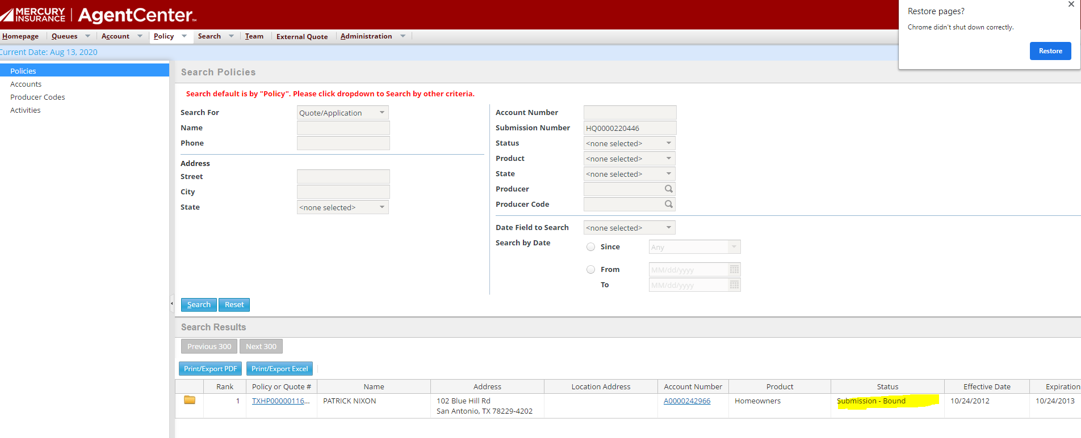

* For all the valid status, bot clicks on HO policy from column 1 to retrieve policy type under qualification screen, proceeds to ppa policy.
* If any other status, bot will create an activity, bot will proceed to 7.2

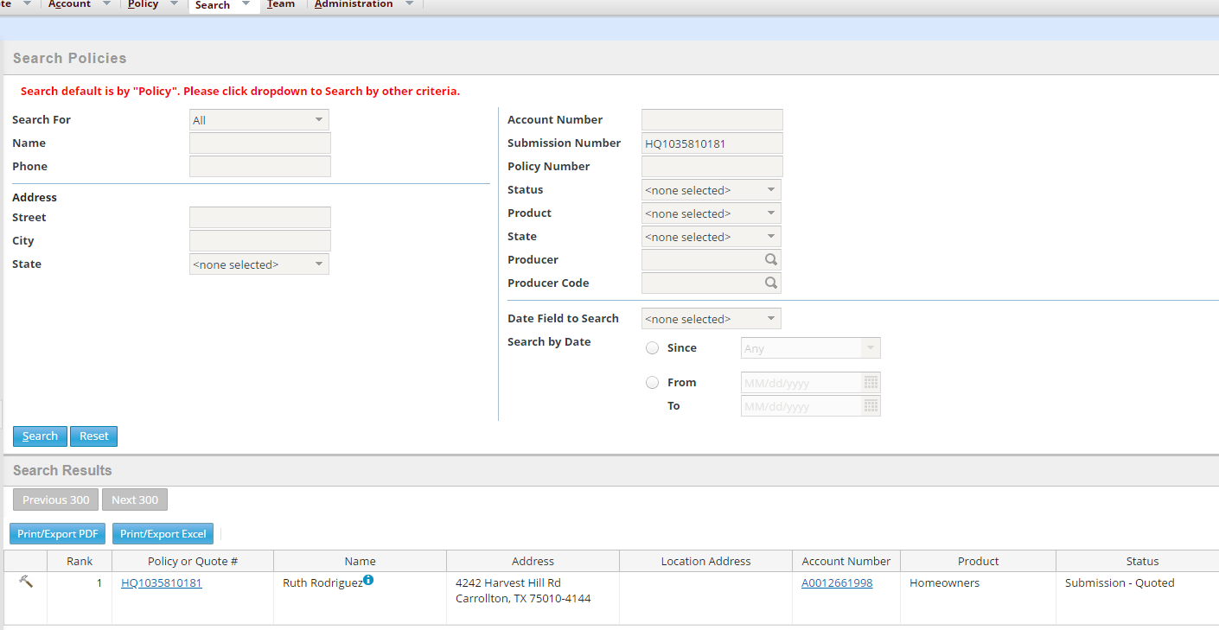

### Bot will process policy change effective today’s date to update policy.

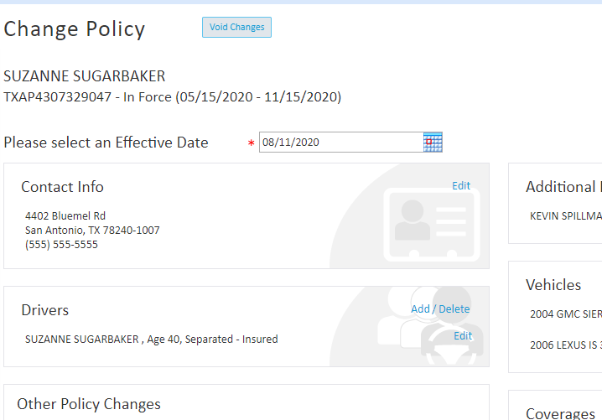

### Bot selects the answer to the “Does the applicant currently have a policy with mercury insurance group?”

### Bot selects below answer depending on HO policy type.

#### Yes – Homeowner

#### Yes – Renters

#### Yes -- Condo



### Bot will update MPD policy and clicks on “Search for Homeowners Policy”.



#### System will validate the MPD policy.

1. If policy is validated successfully, system will display message ‘A bound companion policy is found in the system.
2. Bot validates the message from system and clicks rate button.
3. Bot clicks bind button to issue the policy and bot proceeds to write notes.
4. “**Homie Bot has validated and updated the HO quote number on the policy to a valid HO policy number**.”

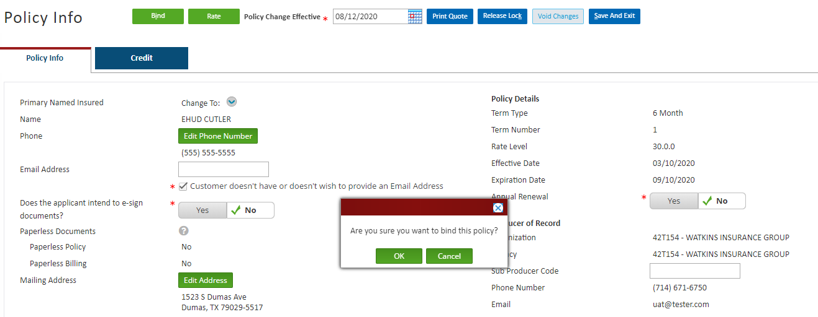

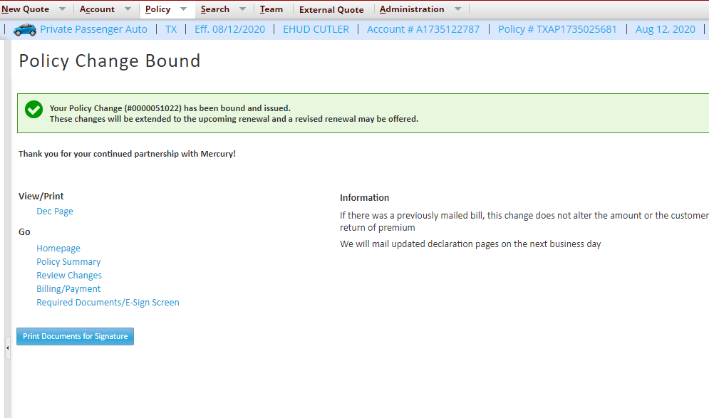

1. If policy is unable to validate, system will display message “**A bound companion policy number has not been found**.” Bot will proceed to click rate and bind the policy, it will create notes “**HOMIE BOT has updated the HO quote number to a policy number.”**

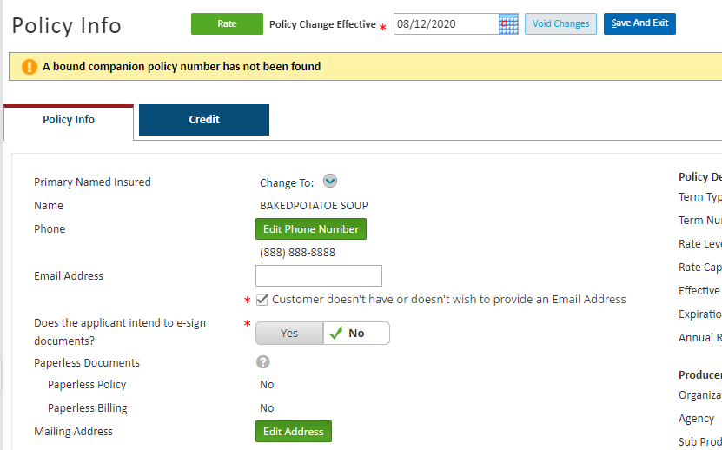

# Note

#### Bot writes notes bases on success or non-success criteria.

**HOMIE BOT has validated and updated the HO quote number on the policy to a valid HO policy number.**

**OR**

**HOMIE BOT has updated the HO quote number to a policy number.**

#### 

#### Bot clicks Quicklinks, then clicks New Note

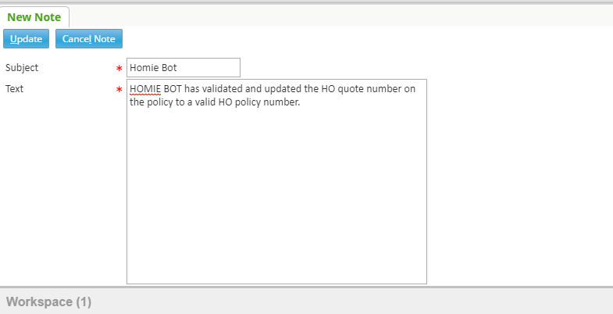

#### New note tab appears, Bot enters the following text:

##### Subject:

###### Homie Bot

##### Text:

###### HOMIE BOT has validated and updated the HO quote number on the policy to a valid HO policy number.

# Login – Guidewire

### User Name: UW_BPA

### Password: Stored in orchestrator

### Role: Manager

### Browser: Google Chrome

### URL:

### <https://transcendpc.mercuryinsurance.com/siteminderagent/forms/gw_pc_login.fcc?TYPE=33554433&REALMOID=06-bfd076a3-e015-4bc0-a1f2-b22912899230&GUID=&SMAUTHREASON=0&METHOD=GET&SMAGENTNAME=prd_gwpc_ag&TARGET=-SM-HTTPS%3a%2f%2ftranscendpc%2emercuryinsurance%2ecom%2fpc%2f>

# Reporting

* Andrew Cheney from business will have access to the report file.

### File location: \\n1brec01a\bpa_data_pr\Homie \Output

### Columns

#### PolicyNumber

#### SuccessFailure

|  |  |
| --- | --- |
| **PolicyNumber** | **SuccessFailure** |
| XXXXXXXXXXX | Success/Failure |

# Error Handling

### If bot experiences any issues while processing the change, email will be send to [DOC_notcompletedUWwork@mercuryinsurance.com](mailto:DOC_notcompletedUWwork@mercuryinsurance.com).

* If Original ho quote looked up is not bound on Search Results page, bot will create activity.

### Email should include subject “MULTI-POLICY VERIFICATION POL # <PPA POL#>” and description includes “Please review Inforce HO Policy Number # <HO Policy Number>”

# Non-Functional requirements

# File location

### Excel file dropped in network folder.

#### File location: \\n1brec01a\bpa_data_pr\Homie\Input

#### File format: Excel

#### Input File Name: Homie _Input.csv

#### Users with access to the network folder

|  |  |
| --- | --- |
| Name | Title |
| Daniel Mancu | UW Analyst |

# Security Considerations

Security is not changing as part of this implementation.

# Application Controls

To ensure that all appropriate application controls are included in the Functional Requirements Document, the Business Analyst must complete the Application Controls Table.

**Application Controls Table**

| ACO # | Application Control Objective (ACO) | Financial Statement Assertion | Applicability Explanation  (Yes or No and why) |
| --- | --- | --- | --- |
| ACO-01 | Ensure **adherence to defined business rules** in the flow and accuracy of processing | Accuracy, Completeness, Validity | Yes, section 5 |
| ACO -02 | Ensure that **only authorized transactions** are input and accepted by the application | Validity | Yes, section 5-6 |
| ACO-03 | Ensure that **only accurate data** are input and accepted by the application | Accuracy | Yes, section 5-6 |
| ACO-04 | Ensure that transactions are **processed completely** (no more, no less) **within an application** | Completeness | Yes, section 5-6 |
| ACO-05 | Ensure that transactions are **processed completely** (no more, no less) **between an application and its internal and external interfaces** (both inbound and outbound) | Completeness | Yes, section 5-6 |
| ACO-06 | Ensure that **system generated transactions** and **values** are **accurate and reliable** | Accuracy | Yes, section 5 |
| ACO-07 | Ensure that **system calculations** are **accurate** | Accuracy | No, there are no system calculations performed by bot |
| ACO-08 | Ensure that **errors and exceptions** (e.g., transaction reversals, overrides, error corrections) **are handled properly**, with the appropriate level of authority and audit trail | Validity, Completeness | Yes, section 5 |